**Sprint 2 Plan, RetailGo,**

**Sprint end date: 11/9/23**

**revised date: 11/9/23**

**Goal**: The goal for sprint 2 is to complete our minimum viable product by implementing the point of sale system for user stories. We will also start on implementing the employee authentication system.

**Task listing, organized by user story:**

User story 1: As an owner, I want toensure that only authorized personnel have access to my store.

*(Total Hours: ~ 16 hours)*

Task 1: Design the system in Figma (1 worked hours)

Task 2: Front end (5 worked hours)

* Set up store registration page
* Clerk webhook for new users

Task 3 Back end (10 worked hours)

* Setup clerk authentication middleware
* Update database for how login works

User story 2:

As an owner, I want to get stock updates in real-time after transactions.

*(Total Hours: ~ 5 hours)*

Task 1: Hooking point of sale system to inventory (5 hours)

* Update checkout process to remove stock from inventory

User story 3:

As an employee, I want to complete customer transactions entirety through the POS

*(Total Hours: ~ 25 hours)*

Task 1: Design the system in Figma (3 worked hours)

* Look at other POS systems for designs

Task 2: Front end (7 worked hours)

- Create a skeleton page

- Allow adding items to cart

- Allow for multiple quantities

- Allow item search

- Search by name, category or id

- Checkout process with stripe

Task 3 Back end (15 worked hours)

* Create schema (1 hour)
* Stripe API integration (~7 hours)
* Update API (~ 7 hours)
  + CRUD Routes for Stores
* Download (potentially upload) inventory as spreadsheet (~ 6 hrs)
* *Added 11/9/23 -* Refactor category system to its own table

∙ **Team roles:** Give a listing of all team members. Next to the team member, list their role(s) for this sprint. Assign each person to at least one role (for example, this role might be "Developer"). This looks like:

Colby Frey - Scrum Master

[Apramay Singh](mailto:asing231@ucsc.edu) - Developer

Giridhar Vadhul - Developer

Leo Asatoorian - Developer/Designer

Jonathan Michel - Backend Developer

David Nguyen - Front-end Developer

∙ **Initial task assignment:** A listing of each team member, with their first user story and task assignment. This should look like:

Colby Frey - Figma design for POS system and Employee management system

[Apramay Singh](mailto:asing231@ucsc.edu) - Clerk Auth Middleware

Giridhar Vadhul - Front end alternate inventory view

Leo Asatoorian - Store registration form/ Stripe integration

Jonathan Michel - CRUD Routes for point of sale

David Nguyen - Front-end for POS

**Scrum sprint 2 inital burnup chart:**

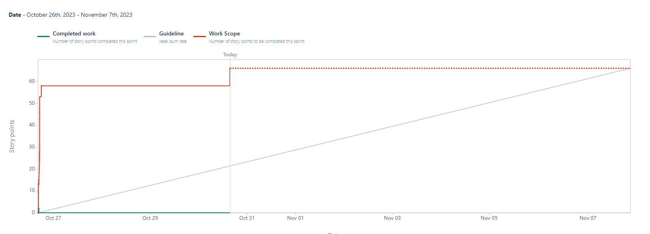

∙ **Initial scrum board:**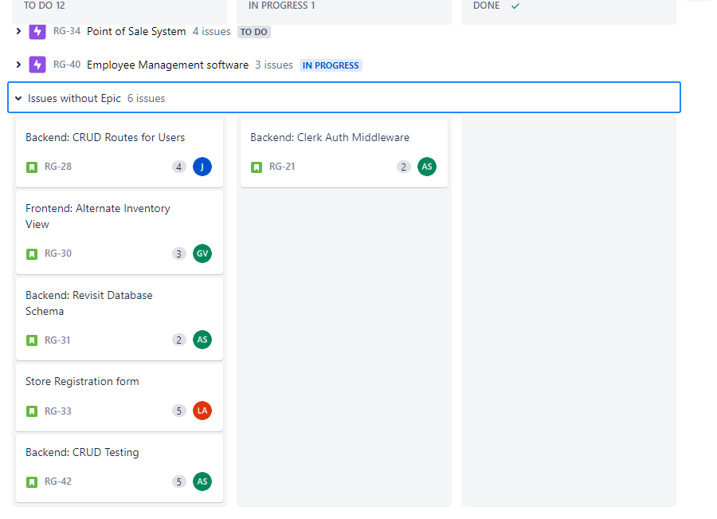

∙ **Scrum times:**

Saturday @ 4 pm

Monday @ 4:30 (TA MEETING)

Thursday @ 4 pm